**How to resolve when hamanchi stops**

**Issue:**

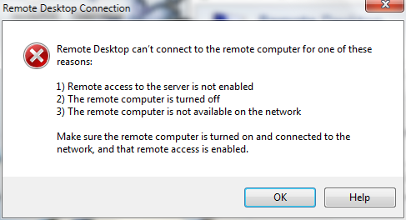

Remote Desktop is unable to access the virtual machine as hamanchi is stopped.

**How to resolve:**

* Open start menu and search for services.smc

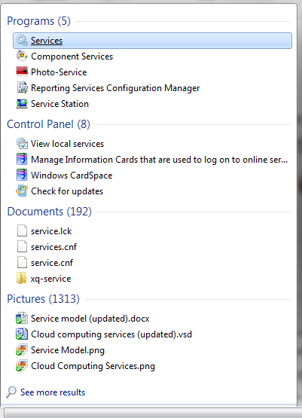

* Open services

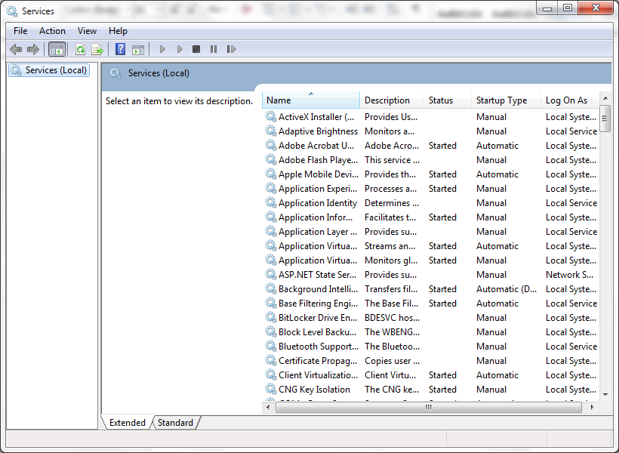

* Find out LogMeIn Hamanchi in the list

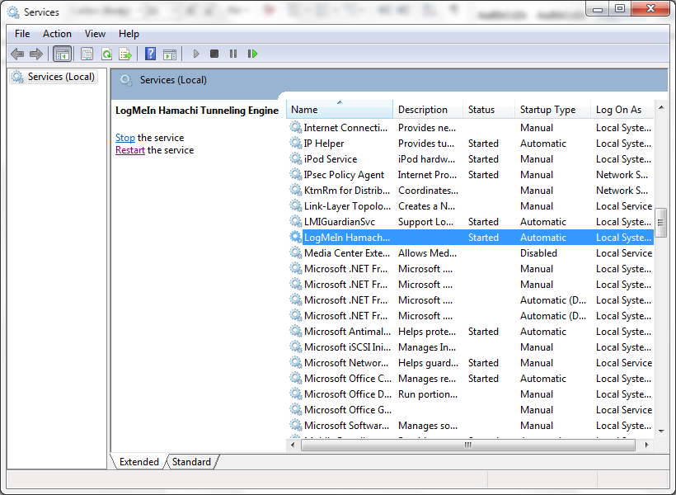

* Press on restart the service

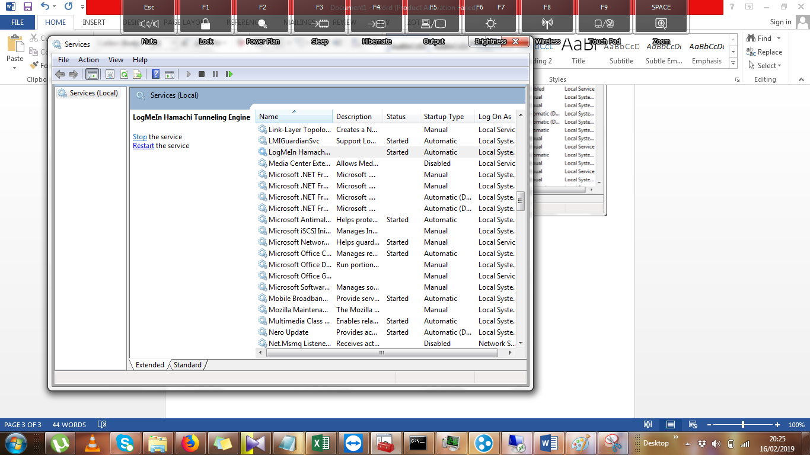

* Turn on LogMeIn Hamanchi. It will work now

